**Merciado Amusement Park**

**Documentation**

|  |  |  |
| --- | --- | --- |
| **Supervisor.** | **Miss Shumaila Naz** | |
| **Batch.** | 2206 F1 | |
| **Group.** | **A** | |
| **Serial No.** | **Enrollment Number** | **Student Name** |
| 1. | 1388281 | Arham Rao |
| 2. | 1345289 | Abdullah Kamal |
| 3. | 1386879 | Muhammad Ahsan Mazhar |
| 4. | 1386877 | Muhammad Daniyal |

**TABLE OF CONTENTS:**

**Certification:** [**4**](https://docs.google.com/document/d/19aYg0_V7WdP6xIdobQFYznaIOTQj5v6G/edit#heading=h.gjdgxs)

**PROBLEM STATEMENT:** [**5**](https://docs.google.com/document/d/19aYg0_V7WdP6xIdobQFYznaIOTQj5v6G/edit#heading=h.1t3h5sf)

**REQUIRMENT SPECIFICATION:** [**6**](https://docs.google.com/document/d/19aYg0_V7WdP6xIdobQFYznaIOTQj5v6G/edit#heading=h.4d34og8)

**Documentation:** [**8**](https://docs.google.com/document/d/19aYg0_V7WdP6xIdobQFYznaIOTQj5v6G/edit#heading=h.1fob9te)

**Screenshots:** [**9**](https://docs.google.com/document/d/19aYg0_V7WdP6xIdobQFYznaIOTQj5v6G/edit#heading=h.2s8eyo1)

**HOME PAGE** [**10**](https://docs.google.com/document/d/19aYg0_V7WdP6xIdobQFYznaIOTQj5v6G/edit#heading=h.17dp8vu)

**CATEGORY** [**11**](https://docs.google.com/document/d/19aYg0_V7WdP6xIdobQFYznaIOTQj5v6G/edit#heading=h.3rdcrjn)

**GALLERY** [**11**](https://docs.google.com/document/d/19aYg0_V7WdP6xIdobQFYznaIOTQj5v6G/edit#heading=h.26in1rg)

**CONTACT US** [**12**](https://docs.google.com/document/d/19aYg0_V7WdP6xIdobQFYznaIOTQj5v6G/edit#heading=h.lnxbz9)

**ABOUT US** [**13**](https://docs.google.com/document/d/19aYg0_V7WdP6xIdobQFYznaIOTQj5v6G/edit#heading=h.35nkun2)

**Hardware/ Software Requirements** [**14**](https://docs.google.com/document/d/19aYg0_V7WdP6xIdobQFYznaIOTQj5v6G/edit#heading=h.1ksv4uv)

**Certification:**

**Submitted to:**

**eProject.aglsm.com**

**Project instructor:**

**shumaila@aptechnorth.edu.pk**

**This is to certify that,**

1. Abdullah Kamal

    Batch code: 2206 F1

2. Arham Rao

     Batch code: 2206 F1

3. Muhammad Ahsan Mazhar

     Batch code: 2206 F1

4. Muhammad Daniyal

Batch code: 2206 F1

**Have successfully designed, develop and submitted the imitation jewelry website.**

.

***TASK SHEET REVIEW 2***

|  |  |  |  |  |  |  |
| --- | --- | --- | --- | --- | --- | --- |
| Project Ref. No.: eP/Advertisement Portal Management System/01 | | Project  title | Date of Preparation of Activity Plan | | | |
| No | Task | Merciado Amusement Park | Actual | Actual | Team-mate | Status |
| Start Date | Days | Names |
| 1 | Build Home Page | 06/08/2022 | 3 | Arham Rao | Complete |
| 2 | Build Feedback, about us, Contact us Page | 12/08/2022 | 4 | Abdullah  Kamal | Complete |
| 3 | Build Gallery Page | 08/08/2022 | 3 | Muhammad  Ahsan  Mazhar | Complete |
| 4 | Build Restaurant Page | 20/08/2022 | 7 | Muhammad  Ahsan  Mazhar | Complete |
| 5 | Begin Code  JavaScript For  The Home | 20/08/2022 | 2 | Abdullah kamal | Complete |
| 6 | Begin Content | 06/08/2022 | 3 | Muhammad  Daniyal | Complete |
| 7 | Begin Code  Support For  Browsers and content |  | 23/08/2022 | 4 | Muhammad Daniyal | Complete |
| 8 | Check Progress and Assign New Tasks |  | Every Alternative Day | - | Arham Rao | Complete |

***TASK SHEET REVIEW 3***

|  |  |  |  |  |  |  |
| --- | --- | --- | --- | --- | --- | --- |
| Project Ref. No.: eP/Advertisement Portal Management System/01 | | Project title | Date of Preparation of Activity Plan | | | |
| No | Task | Merciado Amusement Park | Actual  Start Date | Actual  Days | Team-mate  Names | Status |
| 1 | Check color  format, size,  JavaScript, CSS  responsive in the Home page | 29/08/2022 | 2 | Arham Rao | Complete |
| 2 | Check color  format, size,  JavaScript, CSS  responsive in  About us page | 29/08/2022 | 2 | Abdullah  Kamal | Complete |
| 3 | Check color  format, size,  JavaScript,  responsive in  Feedback, About us, Contact us Page | 29/08/2022 | 4 | Abdullah  Kamal | Complete |
| 4 | Write a  developer guide and web content | 2/09/2022 | 9 | Muhammad  Ahsan  Mazhar | Complete |
| 5 | Write user  Manuals |
| 6 | Overall  inspection of the project | 2/09/2022 | 1 | Arham Rao | Complete |

**Merciado Amusment Park**

**E-project issue date: 29-oct-2022**

**Date of submission: 28-nov-2022**

**Problem Statement**

Merciado Amusement park is now prime focus of the city and nation. It is made by Seth groups of companies. The development of this park took 5 years to get their desired finished product. It has became nation pride now. The area of theme park is about 45 acre land. The Management has put all the efforts to keep the attractions operational. The merciado management wants you to develop the website of the park which should include describing all the attraction of the park and also allow the user to book the ticket online.

**Requirement Specification:**

The Web site is to be created based on the following requirements.

1. The home page must be designed with beautiful color combination with all the required links defined properly. Also all the section of the webpage must be in used to avoid the blank space.
2. Different Zones and attraction, Restaurants, Entertainment, Tickets and Prices, Gallery be described in different webpage.
3. Prices value must be show the differences as per the day (like weekend or weekday or family pack).
4. About us, Contact Us, Disclaimer must be included.
5. Creating an account facility can also be added.
6. Dummy procedure for booking the ticket can be added.
7. Sitemap must be added.
8. Navigation of the project must be made smooth.

**Documentation:**

No project is complete without documentation. In fact, it is one of the most important activities during the development of a project

**Hardware/ Software Requirements**

**Hardware**

* A minimum computer system that will help you access all the tools in the courses is a Pentium 166 or better
* 64 Megabytes of RAM or better

**Software**

* Notepad/HTML editor
* Dreamweaver
* IE 5.0/ Netscape 6.0
* VS CODE

**Screenshots:**

Home page

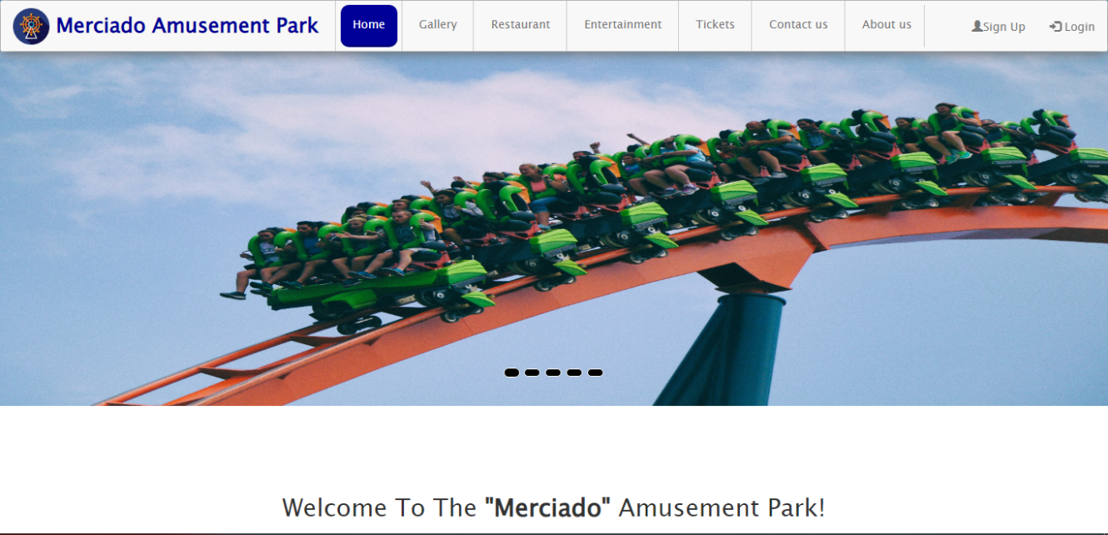

The homepage of **Merciado Amusement Park** gives you the names of

the

other pages of **NAV BAR** in the header. The main body includes an

Background image with images on which the I hover classes are applied

# NAV BAR:

# 

It consists of all the categories and their linking through a dropdown menu. It consists of the pages of Home, about us, contact us and gallery. It is fixed in the top. So, user doesn’t need to scroll again and again.

Footer:

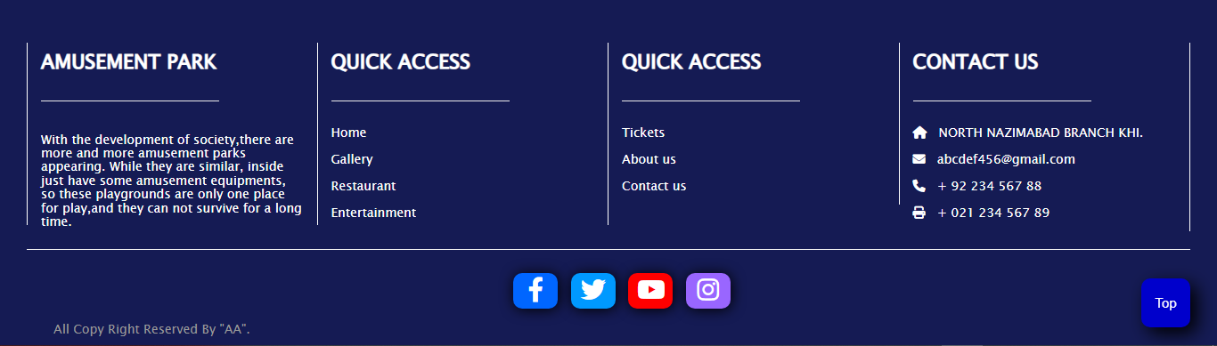

It includes another nav bar which is consist of quick links i.e. order us, about us and feedback form. Services i.e. home, categories, contact us .

GALLERY

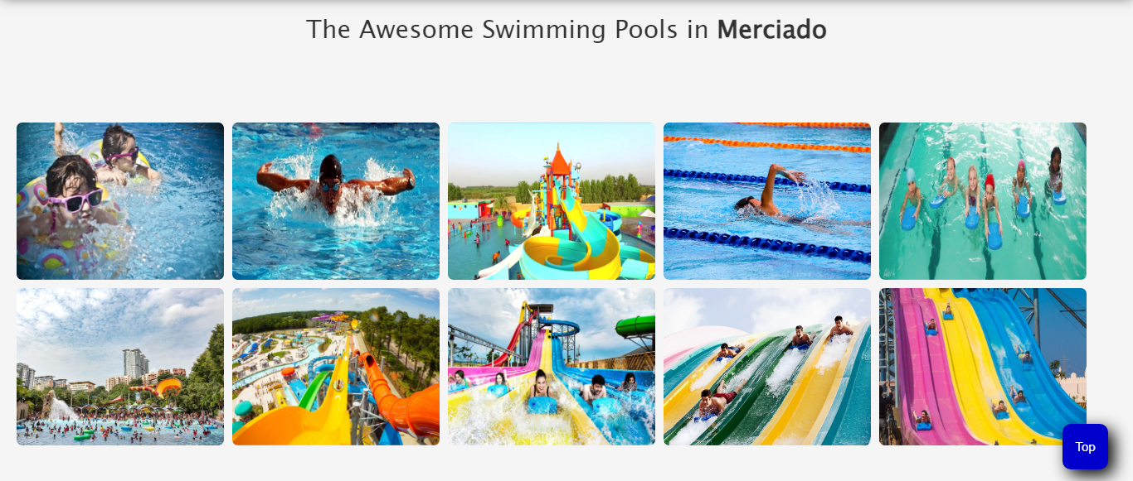

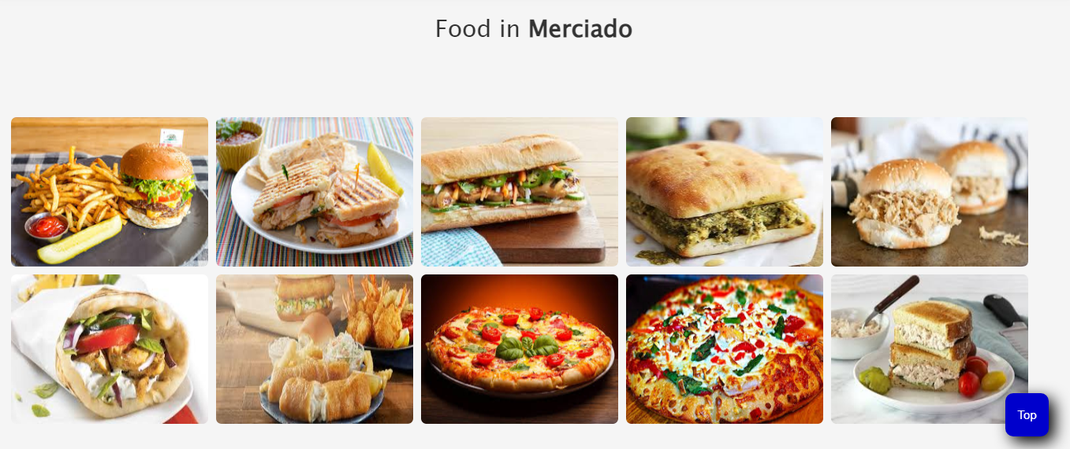

Contact us

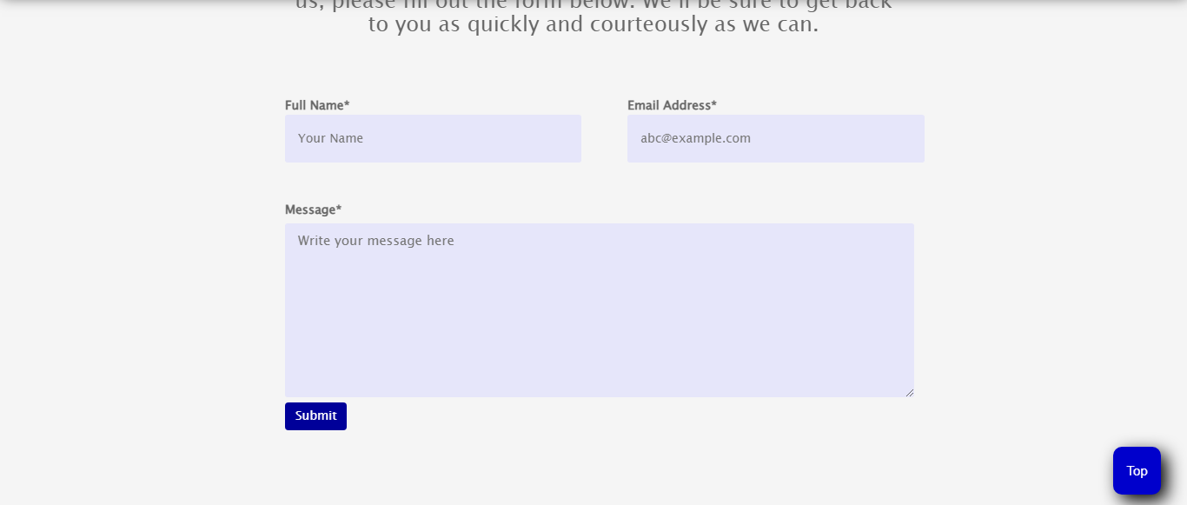

The contact us page is consist of a form. You can connect us or talk to us just by filling this small form and typing the message. The company will reply you hardly in two days max. This page is also consist of navs in both header and footer.

ABOUT US

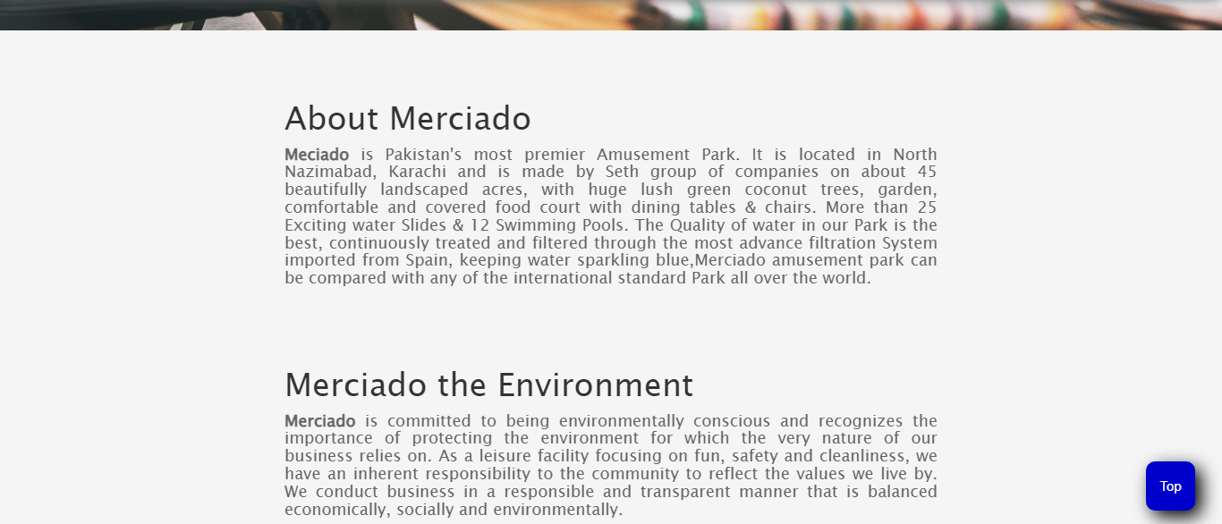

This page gives you the complete detail about us. And our products

Tickets:

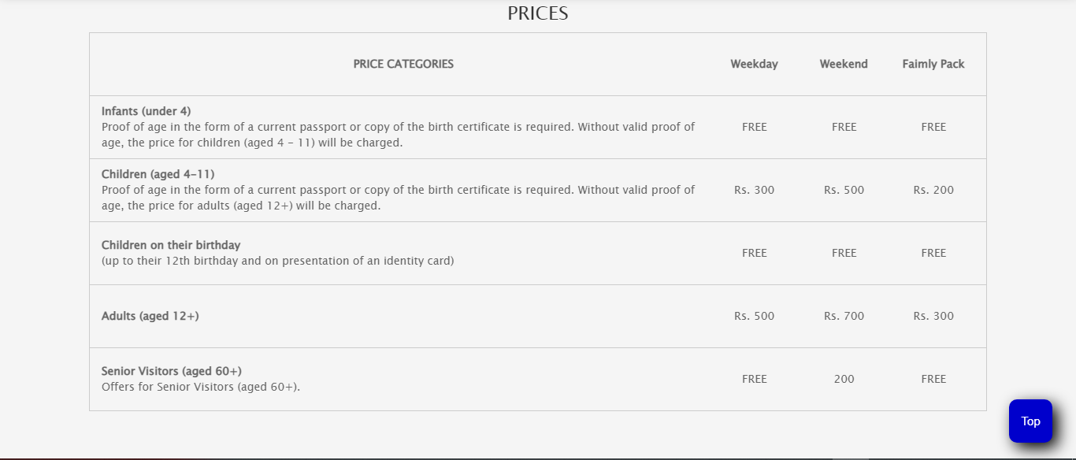

This page gives you the buy now details .